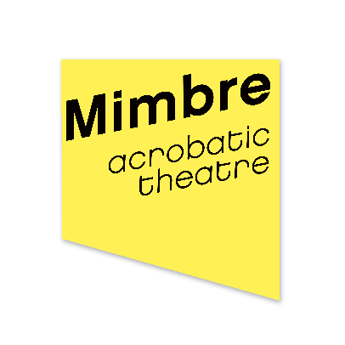

Mimbre
Trustee Information Pack

November 2021

Thank you so much for your interest in joining the Mimbre Board of Trustees!

This pack should contain most of the information you need to make an application. If you have any further questions, or would just like a chat about whether Mimbre is right for you, please feel free to contact Lissy Lovett on lissy@mimbre.co.uk, 020 7613 1068 or 07931353531.

About the role of Trustee
Mimbre’s Board of Trustees provide oversight and strategic direction to the organisation. The number of Trustees at any one time varies between five and nine people, and we always seek to have a mix of different kinds of people to get different views. Additionally:

- Mimbre’s Board of Trustees are also its Directors under company law and have ultimate responsibility for the direction and governance of the organisation, although day-to-day management is delegated to the Artistic and Executive Directors.
- Trustees are appointed for a term of three years, and can be reappointed just once to a maximum of six years.
- Mimbre’s Trustees are volunteers and do not receive payment for their time, although travel and accommodation expenses for Board meetings will be reimbursed.
- All Trustees must make a commitment to safeguard and promote the welfare of the young people that Mimbre work with.
- We offer training and a buddy system to make sure that new Trustees feel supported.

The Board meets four times a year in east or central London and over Zoom, and in addition the Trustees are asked to offer some specific advice, networking or help in their areas of expertise outside of these meetings. Once a year, to coincide with a board meeting, the board also attend a half day ‘away day’ to discuss Mimbre’s strategy in more depth. Mimbre also encourages Board members to attend local performances and events.

A subset of board members including the Chair and Treasurer belong to a finance subcommittee. This group meets a week before each meeting to discuss the quarterly Management Accounts and any other financial matters. Joining this subcommittee is completely optional.

There’s a lot more information about the general role of Trustees here: https://www.gov.uk/guidance/charity-trustee-whats-involved

Again, if you’d like to speak to Lissy further about the responsibilities, her contact details are at the top of this page and in the ‘how to apply’ section.

About the role of Chair
Mimbre is also currently looking for a new Board member specifically to take over the role of Chair. In addition to the responsibilities listed above, the Chair also:
- Chairs the Board meetings
- Will be invited to join occasional meetings by Arts Council England
- Takes some responsibility for the management of the Board as a whole alongside the Executive Director

What we’re looking for
We’d love to speak to anyone with an interest in the arts and/or supporting young people, who’s willing to give up some of their time to support our organisation. We’re looking for trustworthy, positive, helpful people who are able to be critical when necessary but who will also help us improve. You don’t need to have any experience of being on a Board.

At the moment, to make sure our Board covers a range of skills, we’re interested in new Trustees with experience in compliance and governance; communications, PR and marketing; HR and career development and fundraising. But also, as our board members rotate regularly, we are continually looking for new people, so if you have other skills and experience that you’d like to contribute to our company we’d love to hear from you now as well.

Mimbre strongly believes in diversity and to make our board more representative we would really like to encourage applications from people who are in their 20s, 60s, 70s or 80s, people who identify as disabled, people from the global majority (black, Asian or other minority ethnic backgrounds) and people who are working class.

For the role of Chair specifically, as a company with a mission to promote a positive image of women, we’d love to speak to women who are looking to take the next step as leaders.

About Mimbre

The story so far
Mimbre is an international circus, street theatre and performance company producing innovative and extraordinary performances that intrigue and delight. The company can often be seen in unconventional and unexpected settings, stirring emotional connections with a wide range of audiences through their unique blend of breath-taking acrobatic skills, dance, visual poetry and imaginative narratives.

Formed in 1998 and female-led, the creative and performance pedigree of Mimbre’s Artistic Directors Lina Johansson and Silvia Fratelli have earned the company a notable reputation for innovation and creativity, promoting a strong and positive image of women. Mimbre works with artists and collaborators of the highest standard, ensuring that its work retains integrity and skilled expertise.

Based in Hackney, in East London, Mimbre combines national and international touring with a firm engagement in its home locality, ensuring that its excellence in acrobatics and performance form a critical part of the developmental programme for young people in the borough.

In 2018, the company produced its largest show to date, The Exploded Circus, which toured to England, Scotland and Wales in a diverse range of venues – from a 900 seat theatre to a circus tent. In 2019, Mimbre was commissioned to create a large-scale choreography by Dior for Paris Fashion Week. The Covid-19 pandemic of 2020 severely curtailed the organisation’s work, but the short film The Sofa Dance was commissioned by BBC Arts, Arts Council England and The Space and reached more than 300,000 viewers online.

Our plans for 2022 include:
- touring our successful show Lifted to festivals in the UK and Europe;
- our Artistic Directors working on exciting outside projects such as Garsington Opera’s Rusalka;
- co-producing the Disabled-led show Look Mum, No Hands! with Daryl Beeton Productions;
- working with our circus and artist-led sister organisations to improve the sector as a whole;
- and continuing to run our popular youth programme on one of the most deprived housing estates in the UK.

If you’d like to see a bit of our work, there are some lovely videos on Vimeo and YouTube. We recommend watching:

- The Sofa Dance: https://www.youtube.com/watch?v=fR5ILq0d5LA
- The Lifted trailer: https://vimeo.com/352025752
- Highlights of our Dior show: https://vimeo.com/313780586
- The Exploded Circus trailer: https://vimeo.com/281452585
- Mimbre’s World: https://www.youtube.com/watch?v=9z-xuEwvO7c

Mission
Mimbre is a female-led company creating nuanced, breathtaking and highly skilled acrobatic theatre. We use circus and dance innovatively as a physical language to illuminate human connections and promote a positive image of women.

With an artistic voice that is physical and accessible, Mimbre build relationships with broad, non-traditional audiences and participants, creating unexpected moments in unusual spaces and reclaiming some beauty within the urban environment.

Our performances and participation programme reach beyond social, financial and cultural boundaries and find fresh ways to engage, encourage and inspire people, showing that the impossible can be possible on a local, national and international level.

Aims
We are committed to street theatre and work in unconventional settings, creating moments of the unexpected and reclaiming some beauty in the urban environment. Through strong imagery, visual poetry and emotional content, our work aims at a broad and non-traditional theatre audience.

We aim to champion the development of the art of circus in London and the UK through extensive and in-depth artistic research, skill sharing and collaborative work across the boundaries of art forms and national borders, resulting in a continuously enhanced artistic vocabulary and in bold, challenging, highly skilled and visually poetic performances.

In addition, we support the next generation of creative artists, with a vibrant and varied education programme, which includes: a strong and continuous local educational programme with young people in Hackney, professional development opportunities for both upcoming and established artists and a programme of masterclasses and creative projects that create new connections and spark new ideas both within Mimbre and beyond.

Governance, staffing and finance

Organisational setup
Mimbre is a company limited by guarantee (number 06550042) and a registered charity (1153310).

Our charitable aims are: “to advance the arts for the public benefit by the promotion in particular, but not exclusively, of the art of drama.”

Our main funder is Arts Council England, and we also received income from Hackney Council, Trusts and Foundations, fees for our services and donations.

Our turnover is about £250,000 each year.

If you’d like to see our 2022 – 2023 Business Plan, get in touch with Lissy (contact details above)

Organisational chart

Key

Staff team

Silvia Fratelli
Silvia is both an artistic director and performer within Mimbre. She leads on Mimbre’s acrobatic training and well-being programme and investigations, developing Mimbre’s team of core acrobatic performers and manages the company’s international bookings and tour logistics.

Silvia is Italian and lives in Hackney with her partner and two children.

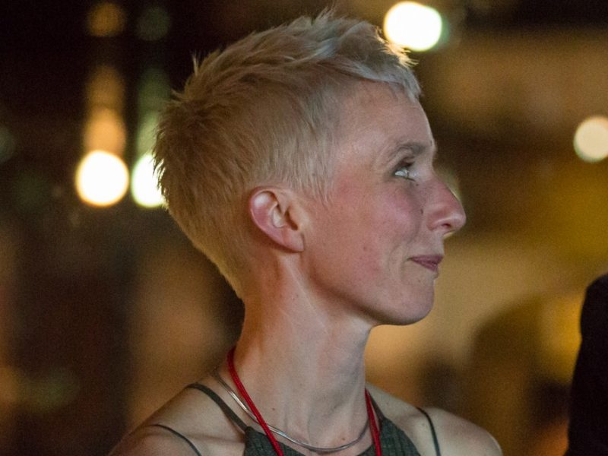 | Lina Johansson  As Joint Artistic Director of Mimbre, Lina leads on the company’s vision and artistic programme, including Mimbre’s programme for local young people. Lina also works on collaborations and external projects with other theatre companies, venues and creatives, as director, specialist choreographer and movement director.  Lina is Swedish and lives in Stoke Newington with one partner, two daughters and a cat.
Lissy Lovett
As Executive Director, Lissy leads on the financial, strategic and operational areas of the company.

Lissy lives alone in Shoreditch and spends a lot of quality time in pubs.
Zsófi Szendrei
Zsófi is Mimbre’s Marketing and Production Coordinator and has a background in Events Management and Theatre & Costume Design.

In her spare time, Zsófi works with a number of female-led organisations and artists, such as being the Creative Director to MONELISE and as an eager volunteer to ethical fashion designer Gung Ho. She was also a core co-conspirator on the feminist initiative Big Art Herstory Project.

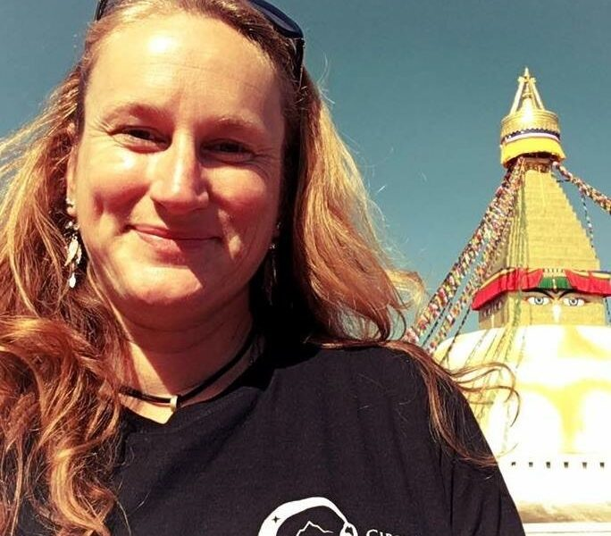 | Anna Strickland  Anna runs Mimbre’s youth programme.  When she’s not at Mimbre, Anna runs Missing Link Productions, one of the premiere circus booking agencies and events companies in the UK and Circus for Survivors, which uses circus skills to help survivors of gendered abuse reclaim their physical narrative.
Tyaine Wright-Shirley
Tyaine joined Mimbre in 2021 as a Company Trainee. Joining the company through Hackney’s Kickstart programme Tyaine is here to assist in admin work, Mimbre’s youth programme and learn skills that will help her build her career. With an interest in art, Tyaine has an appreciation for the creative process and is interested in being able to see and experience the many aspects of Mimbre’s work within the local community and circus arts in general.

Current board

If successful, you will join our enthusiastic Board of experts within the fields of theatre, circus, dance and finance.

Clara Eldridge
Chair
Clara is a seasoned corporate communications professional, providing strategic counsel and communications support across a wide range of industries. She is currently a senior member of the MSL corporate team. (Clara will be stepping down in January 2022)

P Burton-Morgan
P is the artistic director of Metta Theatre. Established in 2005 by visionary Director P Burton-Morgan and Motley trained Designer William Reynolds Metta Theatre is at the forefront of cross-art-form theatre practice, known for combining emotionally powerful performances with imaginative theatricality and striking visual style.

Matthew Hayday
Matthew is the Director of Governance and Compliance for Moat Homes Ltd. (Matthew will be stepping down in January 2022)

Ria Meera Munshi
Ria Meera Munshi is a Bollywood Guinness World Record Holder and celebrity Choreographer. She is the Director of multi-award winning and international dance and theatre company, Ri Ri’s Dance Academy, based in Manchester. Ria has worked with Manchester City Football Club, Lloyds Banking and made a guest appearance on ITVBe’s “The Real Housewives of Cheshire.”

Karen Petersen
Karen has worked within the Artistic Programming team at the Southbank Centre for the past nine years. She is dedicated to working with artists to create accessible, enjoyable and diverse performances. During her career she has produced and managed events for a number of prestigious London arts organisations, including the Roundhouse, Royal Albert Hall, Royal Opera House. She has additionally worked on productions at a number of festivals across the UK, including Edinburgh Festival Fringe, Glastonbury, Latitude and Camp Bestival. Karen is passionate about contemporary circus and is delighted to be a board member for Mimbre. She is looking forward to seeing the company continue to evolve and create inclusive, original and exciting work for audiences and participants.

Jim Robertson
Treasurer
Jim is a Senior Liquidity Reporting and Operations Manager in Asset, Liability and Capital Management for HSBC.

Rosie Rowlands
Rosie is a multi-skilled performer from London. After graduating from the National Centre for Circus Arts, her career has taken her around the globe. From large-scale events in Asia and the Middle East, to UK theatre tours and immersive cabarets, Rosie enjoys connecting with audiences of all ages and sizes, and is most at home when hanging upside down in the air. Since 2015 she has also been juggling the demands of motherhood with her career, and is ever grateful to her family for their unending support!

How to apply
To apply please send a CV and a short covering letter, or a video recording, explaining how you could support Mimbre to Executive Director, Lissy Lovett, on info@mimbre.co.uk. If you’d like to discuss the role first, then feel free to contact Lissy either by email or on 020 7613 1068 or 07931 353531. The deadline is 10am, Monday 20th December 2021.

As part of the application process we’ll invite you to have coffee with one of our senior management team, and also to our next Board meeting as an observer. If you’re applying to be our Chair, we’ll also invite you to meet our outgoing Chair, Clara Eldridge.

We’d be grateful if you could also fill in a completely anonymous equal opportunities form at this link: https://forms.gle/BHQe2jMarPiyzT1VA

If there are any changes we need to make to the application or our working practices to make them accessible to you we’d be glad to do so, please just let us know what you need.

We’re really looking forward to receiving your application!

