Mimbre Performers
Job Description

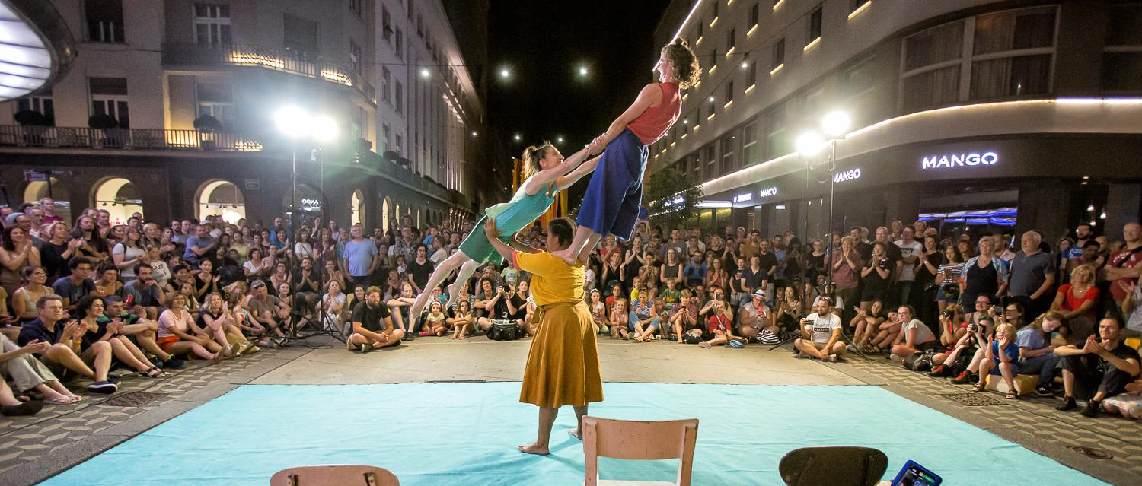

MIMBRE IS LOOKING FOR
NEW PERFORMERS!

We are recruiting for ground-based circus performers with acrobalance skills, specifically in basing and middling, who identify as female or non-binary, to join us for two projects: our next outdoor tour of Lifted, a production created in 2019 and touring since; and to be part of the first stage of development of our 2024 outdoor creation.

Mimbre is keen to work with performers from different backgrounds, and with different abilities and body shapes. We don’t define a strong skill-set as simply particular moves or techniques done to a high technical level; we are seeking performers who can strongly impress an audience with their skills and performance combined and we are prepared to invest in training the right candidate to the show’s required skill set.
We are particularly interested in receiving applications from a Global Majority/ethnically diverse background, but will consider all applicants with the relevant skills and experience.

Key details:
- This opportunity consists of paid training sessions, rehearsals, touring and creation dates from January - September 2023 at ITC/Equity rates or above.
- This is a part-time, fixed term freelance role. Over this time, we estimate a minimum of 20 training dates, 4-5 weeks rehearsal/creation (with potentially more in autumn 2023), and 10+ gigs (ranging from 1 - 5 days each), but this might vary as the tour and partnerships are confirmed.
- We will require initial full availability for the touring period (mid May - mid September), but will provide flexibility whenever possible so performers can combine this project with other work
- Some experience in acrobalance is essential, but we are seeking performers from diverse backgrounds with strong stage presence and creativity, and will invest in training the right people for the role

About ‘Lifted’:

Lifted is a collection of funny, poetic and surprising moments, which explore in different ways what it means when one body is carried by another. Or when one person carries two people. Or when a person doesn't want to be carried. Or when three people find the perfect balance.

This captivating performance experiments with new approaches to Mimbre’s trademark acrobatics. Lifted mixes dance, theatre and circus to celebrate the expressions and impressions that appear when three strong women move, lift and balance each other.

The show is a 35-minute self-contained family friendly performance, created for outdoor festivals, with minimal set and a cast of three performers, currently including Mimbre Joint Artistic Director, Silvia Fratelli, as flyer.

The trailer from the 2019 version is available here, but the show will be adapted and developed according to the new performers’ skills.

New show 2024
We are starting research and development for a new show for 2024, which will again be an outdoor show with three performers. Acrobalance and movement will be part of the physical language, but we are also interested in incorporating other ground-based circus or movement skills, for example handstand, acrodance and dance, tumbling, parkour, juggling, equilibrist, cyr-wheel.
The themes of the show will be developed as part of the research process by the performers and creative team together, through an exploration and devising process, with potential input from audience and outside collaborators.

Timeline

- From mid-January 2023 until the beginning of April 2023 there will be regular training sessions to build up the team’s acrobalance skills. We usually train 2 to 3 times a week in the daytime (between 10am-2pm). Training will take place at Fish Island Circus (Hackney Wick, London) or at National Centre for Circus Arts (Hoxton, London). There will be some weeks of rest and a degree of flexibility with other commitments. Training includes a variety of technical skills, some strength and conditioning, and a weekly company Pilates class.
- In March and/or April there will be two to three weeks of full-time rehearsal: exact dates tbc depending on performer availability and commitments. Rehearsal weeks will be five days.
- Summer tour. The show will tour nationally and internationally from May until late September 2023. Exact dates will be confirmed as the schedule is finalised. The tour base will be in London. Each festival can vary in length from one to five days. We expect to visit at least 10 festivals over the summer.
- New show creation: During 2023 we will be doing between 2-3 weeks research and development towards a new show for 2024. This will consist of R&D weeks in London and potentially as residencies in collaboration with festivals. These will be arranged to fit in with the rest of the summer tour and performers' other commitments.

The company generally travels to gigs in Mimbre’s van, although train and air travel is possible, especially when travelling to Europe.

Please note: this is not a full time position, however because of the late booking approach from festivals, to be able to book the optimal amount of performances we will require first priority on your availability for the summer months.
We work with a system of releasing blocked/pencilled dates at least six weeks ahead of time, and we keep clear communication channels to try to fit around performers' other commitments and opportunities. If you’re considering applying, please let us know what other commitments you have next year, and whether they can realistically be combined with this role.

Role

We are a small, hard-working team and work collaboratively on all aspects of touring; the role will involve being hands on with set-up for each show and general touring activities. This can include long drives in the van, usually rewarded by arriving at some of the most exciting outdoor theatre festivals in the UK and Europe with lovely and enthusiastic audiences.
You’ll also have a chance to gain a close insight into outdoor touring, its logistics and some aspects of producing work for the outdoor theatre industry. As a company we are always happy to share this knowledge and support to help our performers to grow.
If you have any access requirements, please let us know and we will do our utmost to accommodate them.

All training sessions and rehearsals will take place in London and all touring will have London as its base. Because of the spread out nature of the training sessions and the touring, we know from experience that this is a tricky role to take if you are not able to live in London or very near London for the duration of the contract.

Essential attributes
- Experience in acrobalance skills (particularly in basing or middling)
- A wish to explore acrobalance in an experimental and creative context
- Professional experience as a performer
- Strong movement ability – could be in any style
- Comfortable in taking direction as well as contributing creative ideas and material
- Must have the right to work in the UK including having Settled Status if EU citizen and hold a valid passport

Desirable attributes
- Additional skill in another ground-based discipline
- Experience of small-scale and/or outdoor touring
- Clean driving licence and happy to drive a van

Financial and logistical details

- All training sessions, rehearsals and touring are paid at above Equity/ITC Rates of Pay.
- Rehearsal and training fees:
  - £50 per half day training session
  - £550 per 5-day rehearsal week
- Tour fees:
  - £240 for one day
  - £360 for two days
  - £600 for three to five day performance week
  - any additional travel days outside a performance week are paid at £90 per day
- R&D/creation fees:
  - £550 per 5-day week
  - £110 per day
- As mentioned above, we ask performers to keep a commitment to Mimbre for May – September as we book the summer tour. We then work with a system of first option and release dates to enable the performer to take other jobs alongside the tour.
- Per diems/food and accommodation will be covered on tour or outside London.
- Mimbre take the wellbeing of their performers seriously. The performer will undergo a physical assessment with trained physiotherapists at the start of the rehearsal process to create a personalised training plan and training and rehearsal will take the physical needs of the performer into account.

Application and audition process
To apply please send your CV, a short paragraph (or voicenote) outlining what other commitments you have next year and how they can be combined with this role, and a link to your showreel or other videos or images showing your acrobalance and performing skills to Silvia Fratelli at silvia@mimbre.co.uk by 5pm 5th December 2022.

Audition: This will take place from 10am – 5pm w/c 12th December (exact date and location tbc).
When applying please let us know if you have any specific non-availability that week.
If you’d like to apply but not available in December please let us know if you instead could be available for a date in the first half of January (w/c 3rd or w/c 9th January).

The audition will be held as a day workshop covering acrobalance techniques, choreographic tasks related to acrobatics, devising exercises and improvisations. This will also enable applicants to gain an insight into Mimbre’s style and working practices. We aim to create a supportive environment and hopefully the chance for some fun, rather than just a cold, competitive assessment. The audition workshop will be run by Mimbre’s Joint Artistic Directors, Silvia Fratelli and Lina Johansson.

We aim to invite shortlisted applicants to the audition by 8th December.
Travel expenses for applicants to attend the audition will be covered.
If you have any access requirements for the audition or application process please let us know and will do our utmost to accommodate them.

If you would like to discuss the role ahead of your application, please contact Joint Artistic Director, Silvia Fratelli, on silvia@mimbre.co.uk or 07814 650917.

Thank you very much for your interest in this role and please do pass this information on to anyone you know that might be interested.

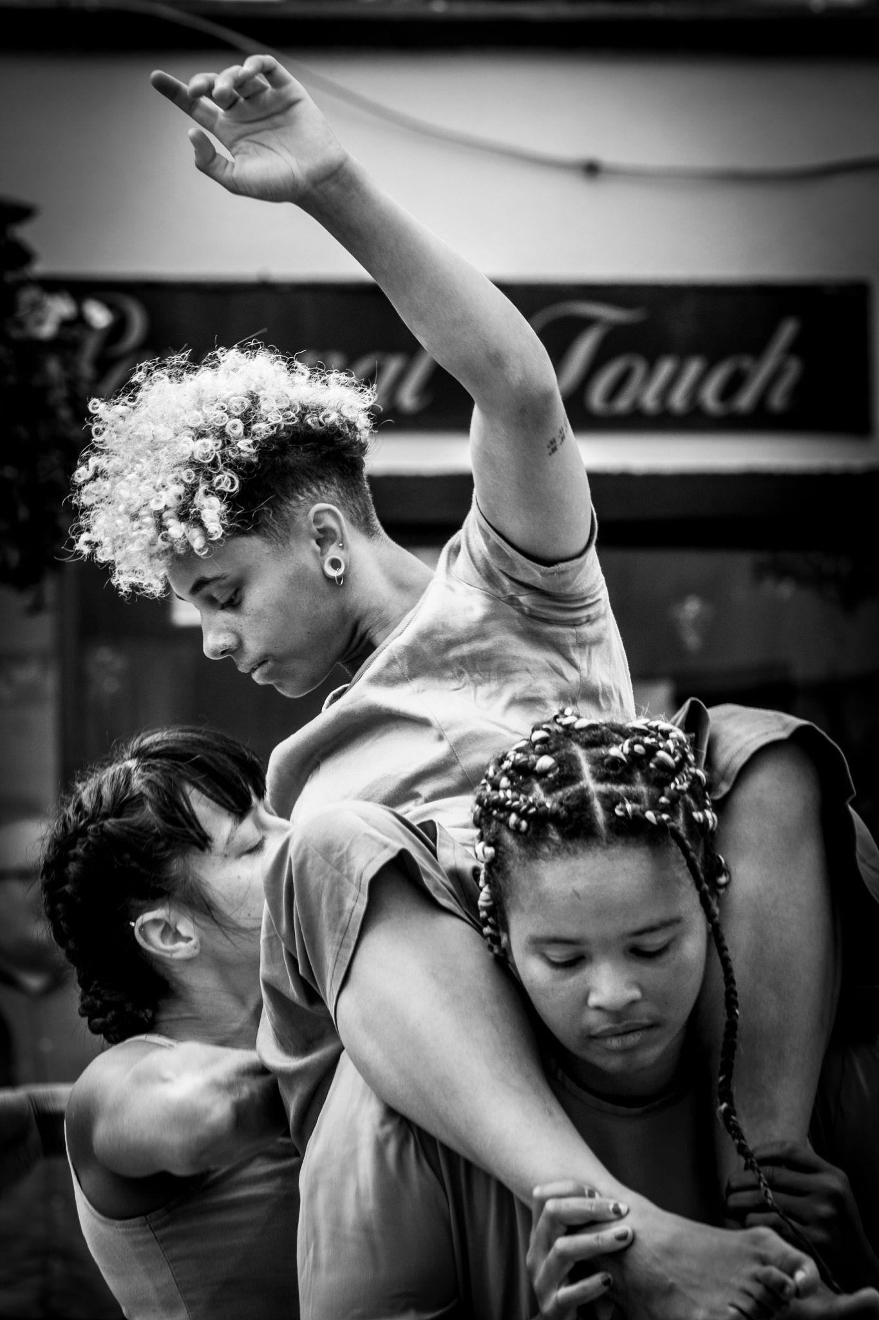
About Mimbre:

Mimbre are a female-led producing company, creating acrobatic theatre for outdoor and unusual settings, touring nationally and internationally, with a strong digital presence. We collaborate across the Creative Industries, as consultants and creators. We run a vibrant local youth programme and an Artist Development Programme for physical performers.

We use circus and movement innovatively as a physical language to illuminate human connections. We pull down barriers to reach beyond social, financial, and cultural boundaries and facilitate everyone’s place within the arts. In all our work we promote a positive, diverse, and inclusive image of cis and trans women as well as non-binary people.

Mimbre is a registered charity. We are a National Portfolio Organisation receiving support from Arts Council England.

Website: www.mimbre.co.uk
Lifted: https://mimbre.co.uk/portfolio_page/lifted/

image credits: Luka Dakskobler, Joe Evans

November 2022

