Mimbre

Trustee Information Pack

  - August 2023

Thank you so much for your interest in joining the Mimbre Board of Trustees!

This pack should contain most of the information you need to make an application. If you have any further questions, or would just like a chat about whether Mimbre is right for you, please feel free to contact Lissy Lovett on lissy@mimbre.co.uk, 020 7613 1068 or 07931353531.

About the role of Trustee
Mimbre’s Board of Trustees provide oversight and strategic direction to the organisation. The number of Trustees at any one time varies between five and nine people, and we always seek to have a mix of different kinds of people to get different views. Additionally:

- Mimbre’s Board of Trustees are also its Directors under company law and have ultimate responsibility for the direction and governance of the organisation, although day-to-day management is delegated to the Artistic and Executive Directors.
- Trustees are appointed for a term of three years, and can be reappointed just once to a maximum of six years.
- Mimbre’s Trustees are volunteers and typically do not receive payment for their time, although travel and accommodation expenses for Board meetings will be reimbursed. However, if not receiving payment for your time is a barrier to you becoming a Trustee, let Lissy know as it is possible to make exceptions.
- All Trustees must make a commitment to safeguard and promote the welfare of the young people that Mimbre work with.
- We ask each board member to contribute financially during the year to the charity – this can be as little as £1, but means that we can say in our annual report that everyone contributes.
- We offer training and a buddy system to make sure that new Trustees feel supported.

The Board meets four times a year in east or central London and over Zoom, and in addition the Trustees are asked to offer some specific advice, networking or help in their areas of expertise outside of these meetings. Once a year, to coincide with a board meeting, the board also attend a half day ‘away day’ to discuss Mimbre’s strategy in more depth. Mimbre also encourages Board members to attend local performances and events.

A subset of board members including the Chair and Treasurer belong to a finance subcommittee. This group meets a week before each meeting to discuss the quarterly Management Accounts and any other financial matters. Joining this subcommittee is completely optional. In the near future we are likely to set up other subgroups on environmental responsibility and expanding our commercial opportunities.

There’s a lot more information about the general role of Trustees here: https://www.gov.uk/guidance/charity-trustee-whats-involved

Again, if you’d like to speak to Lissy further about the responsibilities, her contact details are at the top of this page and in the ‘how to apply’ section.

What we’re looking for
We’d love to speak to anyone with an interest in the arts and/or supporting young people, who’s willing to give up some of their time to support our organisation. We’re looking for trustworthy, positive, helpful people who are able to be critical when necessary but who will also help us improve. You don’t need to have any experience of being on a Board.

At the moment, to make sure our Board covers a range of skills, we’re interested in new Trustees with experience in communications, PR and marketing; fundraising; Outdoor Arts or producing and touring. But also, as our board members rotate regularly, we are continually looking for new people, so if you have other skills and experience that you’d like to contribute to our company we’d love to hear from you now as well.

Mimbre strongly believes in diversity and to make our board more representative we would really like to encourage applications from people who are in their 20s, 60s, 70s or 80s, people who identify as disabled, people from the global majority (black, Asian or other minority ethnic backgrounds) and people who are working class.

About Mimbre
Founded in 1999, Mimbre are a female-led producing company, creating delicate, breathtaking and highly-skilled acrobatic theatre for audiences in outdoor and unusual settings, touring nationally and internationally, with a strong digital presence. We collaborate across the Creative Industries, as consultants and creators. We run a vibrant local youth programme and an Artist Development Programme for physical performers.
We use circus and movement innovatively as a physical language to illuminate human connections. We pull down barriers to reach beyond social, financial, and cultural boundaries and facilitate everyone’s place within the arts. In all our work we aim to challenge gender stereotypes and promote a positive, diverse, and inclusive image of cis and trans women as well as non-binary people.
We make at least two productions each year, including at least one tour, typically reaching around 20,000 live audiences from a wide range of backgrounds. In the last five years, our digital reach has been 3.5m. Partners include Dior, the RSC, The Lowry, National Centre for Circus Arts, Garsington Opera, Greenwich + Docklands International Festival and Stockton International Riverside Festival.
Our youth programme, Mimbre Youth, is rooted in the communities of our local borough of Hackney. It includes classes, community days, performance projects and progress routes. It is a place where young people can express themselves creatively, gain confidence and work as a team. Mimbre Youth focuses on access, inclusion and excellence, and pulls down barriers to enable every child to thrive, regardless of means or abilities.
Our Artist Development Programme advances circus and leadership through professional development initiatives, artistic research and knowledge sharing. We focus on mid-career performers, women, non-binary artists and those from under-represented backgrounds.
A collaborative approach permeates all aspects of our work, from our company structure to our relationship with our performers, audiences and participants. Working with a wide variety of artists, technical innovators and educators, across art forms and borders, allows us to continuously enhance our artistic vocabulary and create bold, challenging and highly skilled work.
If you’d like to see a bit of our work, there are some lovely videos on Vimeo and YouTube. We recommend watching:

- Eye Ear You, our collaboration with designer Shona Heath: https://vimeo.com/781495865
- Highlights of our Dior show: https://vimeo.com/313780586
- Our recent ‘Acrolab’: https://www.youtube.com/watch?v=cQ-mrebrDkM
- Our most recent showreel: https://vimeo.com/757151597
- The Look Mum, No Hands! trailer: https://www.youtube.com/watch?v=YTA924OJo_c
- The Lifted trailer: https://www.youtube.com/watch?v=nnPcD0YdRK4&list=PLlWnLGNpB4fVT7TXsw0p0knQeV0Xqs-4E

Governance, staffing and finance

Organisational setup
Mimbre is a company limited by guarantee (number 06550042) and a registered charity (1153310).

Our charitable aims are: “to advance the arts for the public benefit by the promotion in particular, but not exclusively, of the art of drama.”

Our main funder is Arts Council England, and we also received income from Hackney Council, Trusts and Foundations, fees for our services and donations.

Our turnover is about £250,000 each year.

If you’d like to see our 2023 – 2026 Business Plan, get in touch with Lissy (contact details above)

Organisational chart

Staff team

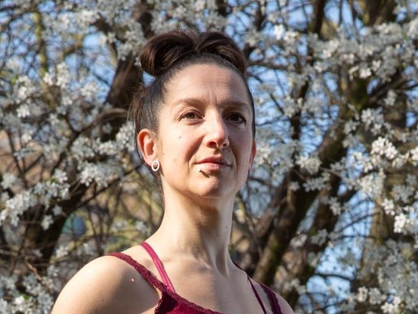 | Silvia Fratelli  Silvia is both an artistic director and performer within Mimbre. She leads on Mimbre’s acrobatic training and well-being programme and investigations, developing Mimbre’s team of core acrobatic performers and manages the company’s international bookings and tour logistics.  Silvia has been standing on her hands for over 25 years and has performed shows all over the world. She speaks Italian, English, Spanish and French.
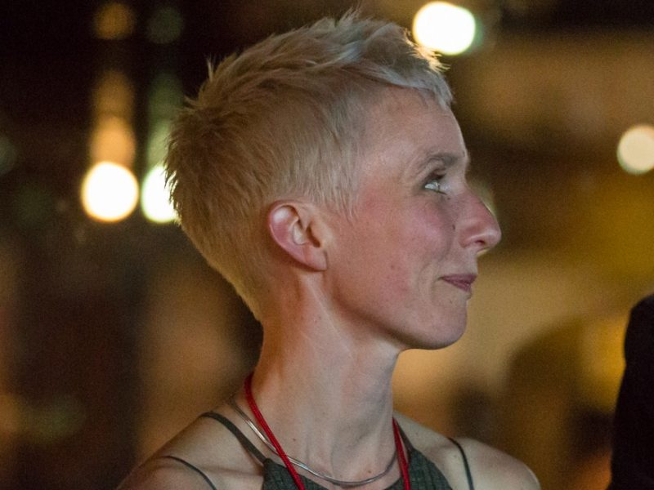 | Lina Johansson  As Joint Artistic Director of Mimbre, Lina leads on the company’s vision and artistic programme, including Mimbre’s programme for local young people. Lina also works on collaborations and external projects with other theatre companies, venues and creatives, as director, specialist choreographer and movement director.  Lina is Swedish and lives in Stoke Newington with one partner, two daughters and a cat.
Lissy Lovett
As Executive Director, Lissy leads on the financial, strategic and operational areas of the company.

Lissy lives alone in Shoreditch and spends a lot of quality time in pubs, theatres and football grounds.
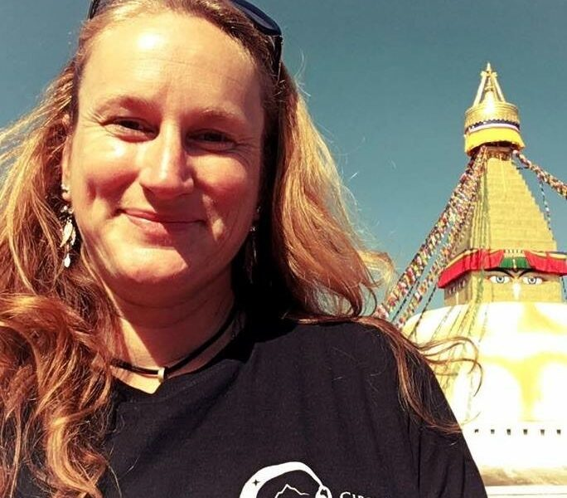 | Anna Strickland  Anna is Mimbre’s Fundraising Manager, focusing on the youth programme.  When she’s not at Mimbre, Anna runs Missing Link Productions, one of the premiere circus booking agencies and events companies in the UK and Circus for Survivors, which uses circus skills to help survivors of gendered abuse reclaim their physical narrative.

Current board

If successful, you will join our enthusiastic Board of experts within the fields of theatre, circus, dance and finance.

Aramide Ogunlana
Chair
Aramide is a seasoned investment professional, most recently working as a product specialist for niche private credit strategies. She is passionate about women’s issues and also sits on the board of Rights of Women. Outside of work she is a budding aerialist and pre-ferment enthusiast.

Ria Meera Munshi
Ria Meera Munshi is a Bollywood Guinness World Record Holder and celebrity Choreographer. She is the Director of multi-award winning and international dance and theatre company, Ri Ri’s Dance Academy, based in Manchester. Ria has worked with Manchester City Football Club, Lloyds Banking and made a guest appearance on ITVBe’s “The Real Housewives of Cheshire.”

Jim Robertson
Treasurer
Jim is a Senior Liquidity Reporting and Operations Manager in Asset, Liability and Capital Management for HSBC.

Jessica Mai Sims
Jessica has over fifteen years’ experience of working in research in the public, academic and voluntary sectors. Currently she is employed by University College London where she manages a national biomedical infrastructure project on biobanking. There she is also involved in initiatives to improve gender and race equality within the university’s policies and practices.

Alice Wordsworth
Alice grew up in Salisbury and is now based in London and Amsterdam. She is currently the Resident Assistant Director on A Little Life, at The Harold Pinter Theatre. Alice is Resident Director for Amsterdam on Stage, working in translation on immersive productions and Associate Director of Bric a Brac, international Lecoq trained devising company. She was Resident Assistant Director at the Unicorn Theatre (2019/20), The UK’s leading theatre for Young People. Alice was recipient of the Peter-Cheeseman Award for Most Developed Director (2020), the JMK Assistant Director Bursary at Salisbury Playhouse (2018) and a Young Vic Outreach Bursary (2018).

How to apply
To apply please send a CV and a short covering letter, or a video recording, explaining how you could support Mimbre to Executive Director, Lissy Lovett, on info@mimbre.co.uk. If you’d like to discuss the role first, then feel free to contact Lissy either by email or on 020 7613 1068 or 07931 353531. The deadline is 10am, Monday 2nd October 2023 but we’d be happy to hear from you before then too.

As part of the application process we’ll invite you to have coffee with one of our senior management team, and also to our next Board meeting as an observer.

We’d be grateful if you could also fill in a completely anonymous equal opportunities form at this link: Mimbre Equal Opportunities Monitoring Form (google.com).

If there are any changes we need to make to the application or our working practices to make them accessible to you we’d be glad to do so, please just let us know what you need.

We’re really looking forward to receiving your application!

https://www.gov.uk/government/publications/trustee-expenses-and-payments-cc11/trustee-expenses-and-payments#paying-for-trusteeship

